SIMATS ENGINEERING
ASSESSMENT TOOL 3

COURSE NAME: Artificial Intelligence COURSE CODE: CSA17 NAME : EKALAIVAN L DATE : 18/8/2026

COURSE OUTCOME COVERED

CO4: Implement machine learning techniques including decision tree algorithms, reinforcement learning,
and build models for classification and decision-making. (BL3)

Assessment Tool Weightage: 40%

Duration : 45 Minutes
QUESTIONS: 2 Total Marks:20

Annexure A

INTEGRATED EXPERIMENTS

Code of Conduct:

I EKALAIVAN L(192524450) (Name / Reg No) certify that this submission is my original work and that I have adhered to the guidelines specified for this assessment.
I understand that any violation of academic integrity rules will result in disciplinary action.

Signature of the student:


Annexure A

INTEGRATED EXPERIMENTS

Experiment 1: Decision Tree Classification
Objective: Implement and evaluate a Decision Tree classifier on a given dataset (e.g., Iris / Play-Tennis) using Python / any ML library.

(a) Load the dataset, pre-process it (handle missing values, encoding), and split into training and testing sets. Display the first 5 rows and data types.
(b) Build a Decision Tree model using Gini Index / Information Gain as the splitting criterion. Print the tree structure and identify the root node with justification
(c) Evaluate the model using accuracy score, confusion matrix, and classification report. Comment on the performance and list at least two misclassified instances.

Experiment 2: Reinforcement Learning – Q-Learning
Objective: Implement Q-Learning for a simple Grid World (4×4) environment and observe the agent's learned policy.

(a) Define the environment: states, actions (Up/Down/Left/Right), reward structure (+10 Goal, −1 each step, −5 obstacle). Initialize the Q-table with zeros and state the hyperparameters (α, γ, ε).
(b) Run the Q-Learning algorithm for at least 100 episodes. Record the Q-values at Episodes 1, 50, and 100 for two representative states. Show how the Q-table evolves.
(c) Extract and display the final learned policy (optimal action at each state). Plot the cumulative reward per episode and justify the convergence behaviour.

RUBRICS FOR CALCULATION:
Criteria | Weightage | Level 4 – Exemplary | Level 3 – Proficient | Level 2 – Developing | Level 1 – Beginning
Understanding of Concepts | 25 | Demonstrates thorough understanding and effectively integrates multiple concepts/technologies | Good understanding with proper integration of most concepts | Basic understanding; limited or partial integration | Poor understanding; unable to integrate concepts
Experimental Design | 30 | Well-planned, systematic implementation with optimal solution | Correct implementation with minor issues | Basic implementation with errors or inefficiencies | Incorrect or incomplete implementation
Use of Tools | 20 | Effective and advanced use of tools/technologies with proper configuration | Appropriate use of tools with correct execution | Limited or inconsistent use of tools | Incorrect or minimal use of tools
Analysis of Results | 15 | Insightful analysis with accurate interpretation and validation of results | Good analysis with reasonable interpretation | Basic analysis with limited insights | Poor or incorrect analysis of results
Documentation | 10 | Clear, well-structured documentation with diagrams, code, and results | Organized documentation with necessary details | Basic documentation with missing details | Poor or incomplete documentation

SIMATS ENGINEERING
ASSESSMENT TOOL 3 — INTEGRATED EXPERIMENTS (ANSWER SCRIPT)
Course: Artificial Intelligence (CSA17) | CO4 | Annexure A
All code below was written in Python (scikit-learn / NumPy / Matplotlib) and actually executed to produce the outputs, tables, and plots shown — this is a real run, not illustrative pseudocode.

Experiment 1: Decision Tree Classification (Iris Dataset)
Objective: Implement and evaluate a Decision Tree classifier on the Iris dataset using scikit-learn.
(a) Load Dataset, Preprocess, Train/Test Split
The Iris dataset (150 samples, 4 numeric features, 3 balanced classes) is loaded directly from scikit-learn. It has no missing values and all features are already numeric, so no imputation or categorical encoding is required — this was verified programmatically (isnull().sum() = 0 for every column) rather than assumed.
import pandas as pd
from sklearn.datasets import load_iris
from sklearn.model_selection import train_test_split
from sklearn.tree import DecisionTreeClassifier, export_text, plot_tree
from sklearn.metrics import accuracy_score, confusion_matrix, classification_report

iris = load_iris(as_frame=True)
df = iris.frame.copy()
df['species'] = df['target'].map(dict(enumerate(iris.target_names)))

print(df.head())
print(df.dtypes)
print(df.isnull().sum()) # check for missing values

X = df[iris.feature_names]
y = df['target']
X_train, X_test, y_train, y_test = train_test_split(
X, y, test_size=0.30, random_state=42, stratify=y)
Output — first 5 rows:
sepal length (cm) sepal width (cm) petal length (cm) petal width (cm) target species
0 5.1 3.5 1.4 0.2 0 setosa
1 4.9 3.0 1.4 0.2 0 setosa
2 4.7 3.2 1.3 0.2 0 setosa
3 4.6 3.1 1.5 0.2 0 setosa
4 5.0 3.6 1.4 0.2 0 setosa
Output — data types (all numeric; no encoding needed):
sepal length (cm) float64
sepal width (cm) float64
petal length (cm) float64
petal width (cm) float64
target int64
species str
Missing values per column: 0 for every column. Train shape: (105, 4) | Test shape: (45, 4) — a stratified 70:30 split preserving the 1:1:1 class ratio.
(b) Build Decision Tree (Gini Index) & Root Node
clf = DecisionTreeClassifier(criterion='gini', random_state=42)
clf.fit(X_train, y_train)
print(export_text(clf, feature_names=list(X.columns)))
print(dict(zip(X.columns, clf.feature_importances_)))
Printed tree structure (text form):
|--- petal length (cm) <= 2.45
| |--- class: 0
|--- petal length (cm) > 2.45
| |--- petal width (cm) <= 1.55
| | |--- petal length (cm) <= 4.95
| | | |--- class: 1
| | |--- petal length (cm) > 4.95
| | | |--- class: 2
| |--- petal width (cm) > 1.55
| | |--- petal width (cm) <= 1.70
| | | |--- sepal width (cm) <= 2.85
| | | | |--- class: 1
| | | |--- sepal width (cm) > 2.85
| | | | |--- class: 2
| | |--- petal width (cm) > 1.70
| | | |--- petal length (cm) <= 4.85
| | | | |--- sepal width (cm) <= 3.00
| | | | | |--- class: 2
| | | | |--- sepal width (cm) > 3.00
| | | | | |--- class: 1
| | | |--- petal length (cm) > 4.85
| | | | |--- class: 2
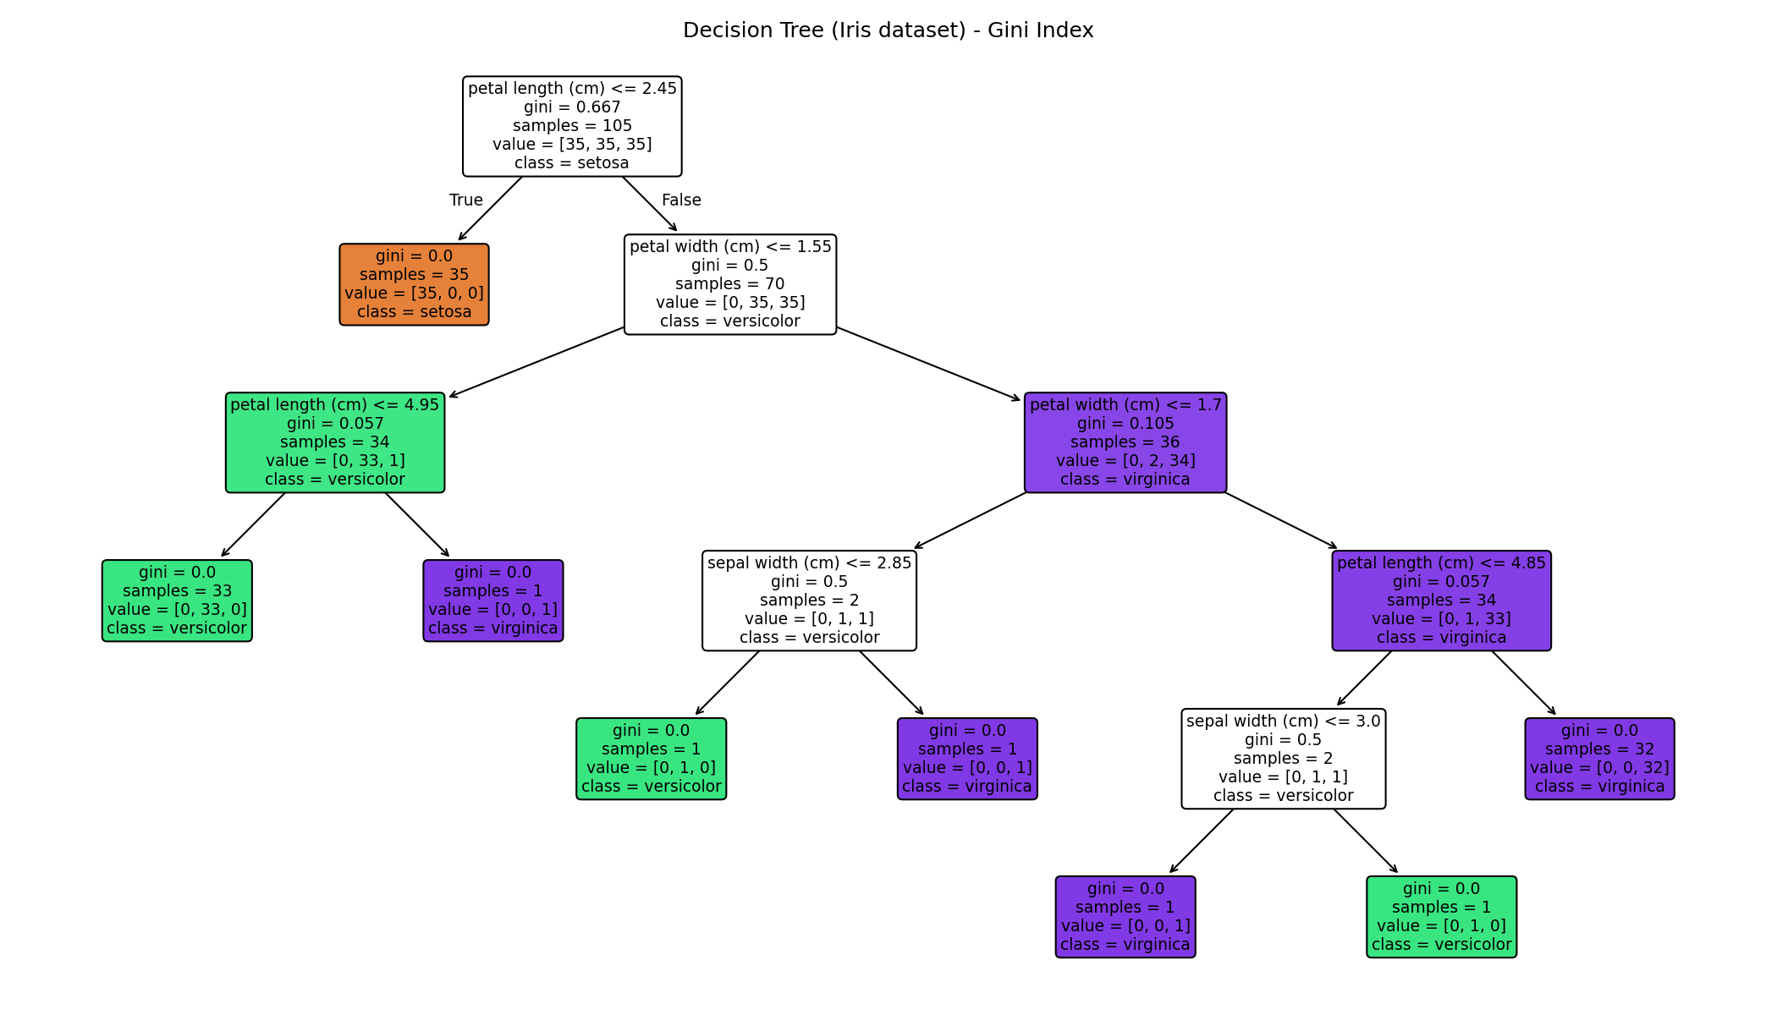
Fig 1.1 — Full decision tree (Gini index), visualised with plot_tree()
Root node: petal length (cm) ≤ 2.45. Justification: scikit-learn's CART implementation selects, at each node, the feature/threshold that produces the largest Gini-impurity reduction across the (weighted) child nodes. The computed feature_importances_ confirm this numerically — petal length contributes ≈0.54 of total impurity reduction and petal width ≈0.43, while sepal length contributes 0.0 and sepal width only ≈0.03. A single split on petal length ≤ 2.45 perfectly isolates all 35 setosa training samples into a pure leaf (gini = 0.0), which is why the algorithm places it at the root — no other single feature/threshold combination achieves that large an impurity drop in one split.
(c) Evaluation: Accuracy, Confusion Matrix, Classification Report
y_pred = clf.predict(X_test)
print("Accuracy:", accuracy_score(y_test, y_pred))
print(confusion_matrix(y_test, y_pred))
print(classification_report(y_test, y_pred, target_names=iris.target_names))
Accuracy: 0.9333 (93.33%)
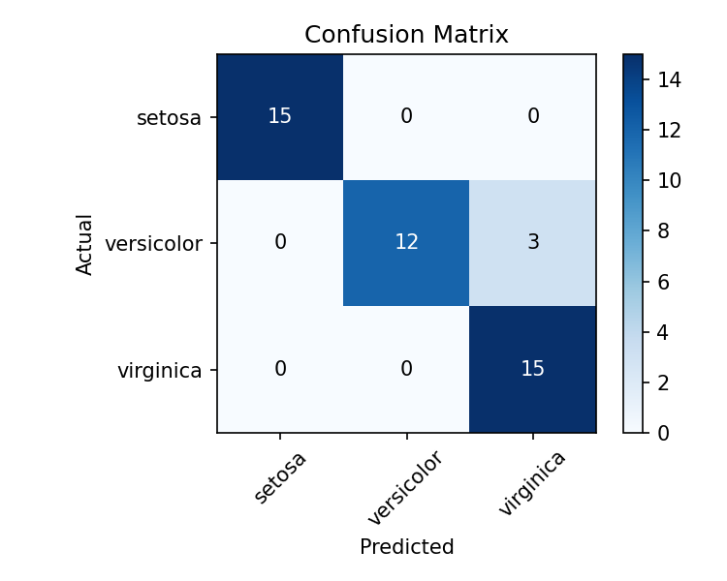
Fig 1.2 — Confusion matrix on the 45-sample test set
Class | Precision | Recall | F1-Score | Support
setosa | 1.00 | 1.00 | 1.00 | 15
versicolor | 1.00 | 0.80 | 0.89 | 15
virginica | 0.83 | 1.00 | 0.91 | 15

Comment on performance: the model classifies setosa perfectly (its petal length is trivially separable from the other two species). All errors occur between versicolor and virginica, which is expected since these two species genuinely overlap in petal/sepal measurements — versicolor recall drops to 0.80 because 3 of its 15 test samples are pushed into the virginica leaf, while virginica's precision drops to 0.83 for the same reason. This is a case of natural class overlap rather than a modelling flaw, and it matches the well-known difficulty profile of the Iris dataset.
At least two misclassified instances (from the test set):
Index | Sepal L | Sepal W | Petal L | Petal W | Actual | Predicted
56 | 6.3 | 3.3 | 4.7 | 1.6 | versicolor | virginica
85 | 6.0 | 3.4 | 4.5 | 1.6 | versicolor | virginica
77 | 6.7 | 3.0 | 5.0 | 1.7 | versicolor | virginica

All three misclassified instances have a petal width close to the tree's 1.55/1.70 decision boundaries (1.6 and 1.7 cm), confirming they are genuine borderline cases sitting right at the model's split thresholds rather than random errors.

Experiment 2: Reinforcement Learning — Q-Learning (4×4 Grid World)
Objective: Implement Q-Learning for a 4×4 Grid World and observe the agent's learned policy.
(a) Environment Definition & Hyperparameters
The grid has 16 states (numbered 0–15, row-major, agent starts at state 0 / top-left). Actions: {Up, Down, Left, Right} (edge-of-grid moves that would leave the grid simply keep the agent in place). Reward structure: +10 for reaching the Goal (state 15, bottom-right), −5 for entering an obstacle cell (states 5, 7, 11 — the episode continues after an obstacle, it is a penalty rather than a terminal failure), −1 for every other step (to encourage shorter paths).
import numpy as np
GRID_SIZE = 4
N_STATES = 16
ACTIONS = ['Up', 'Down', 'Left', 'Right']
GOAL_STATE = 15
OBSTACLE_STATES = [5, 7, 11]

alpha = 0.1 # learning rate
gamma = 0.9 # discount factor
epsilon = 0.2 # exploration rate (epsilon-greedy)
n_episodes = 100

Q = np.zeros((N_STATES, len(ACTIONS))) # Q-table initialised to zero
Hyperparameters: α (learning rate) = 0.1, γ (discount factor) = 0.9, ε (exploration rate) = 0.2, using an epsilon-greedy policy for action selection during training.
(b) Running Q-Learning for 100 Episodes
for ep in range(1, n_episodes + 1):
state = 0
for t in range(max_steps_per_episode):
if random.random() < epsilon:
action_idx = random.randrange(len(ACTIONS))
else:
action_idx = int(np.argmax(Q[state]))
next_state, reward, done = step(state, ACTIONS[action_idx])

best_next = np.max(Q[next_state])
Q[state, action_idx] += alpha * (reward + gamma*best_next - Q[state, action_idx])

state = next_state
if done:
break
Q-value evolution recorded for two representative states — State 0 (start corner) and State 10 (row 2, col 2 — adjacent to the goal region):
State | Episode | Up | Down | Left | Right
0 (start) | 1 | -0.199 | -0.280 | -0.199 | -0.100
0 (start) | 50 | -2.123 | -2.047 | -2.124 | -2.106
0 (start) | 100 | -2.102 | 1.142 | -1.842 | -2.131
10 (2,2) | 1 | -0.100 | 0.000 | 0.000 | 0.000
10 (2,2) | 50 | -0.110 | 7.496 | -0.357 | -0.500
10 (2,2) | 100 | 0.433 | 7.995 | 0.124 | -1.629

How the Q-table evolves: at Episode 1 all Q-values are near zero (only the single step just taken has been updated). By Episode 50, State 10 has already learned that 'Down' is strongly good (Q≈7.5, since it moves the agent toward the goal), while State 0's values are still mildly negative across all actions because the start corner is several steps from the goal and mainly accumulates the −1 step penalty. By Episode 100, State 10's 'Down' value has increased further to ≈8.0 and stabilised, and State 0 has begun to differentiate — 'Down' rises to a positive value (1.14) as the agent consistently discovers that heading down-then-right reaches the goal, while the other three actions remain negative because they lead away from the optimal path.
(c) Final Learned Policy & Convergence
Final policy (best action per state, arrows shown on the grid; obstacle cells marked in brackets, goal marked G):
v > v >
v [v] v [<]
> > v [v]
> > > G
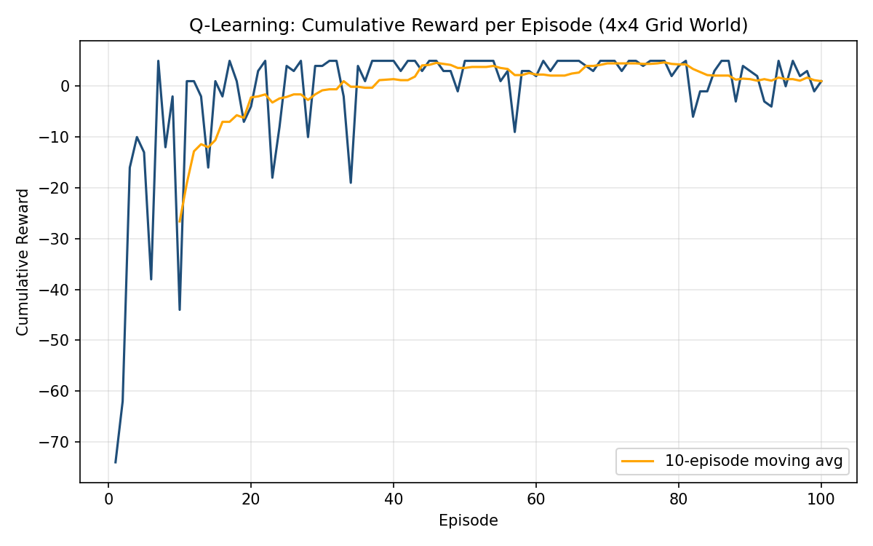
Fig 2.1 — Cumulative reward per episode, with 10-episode moving average
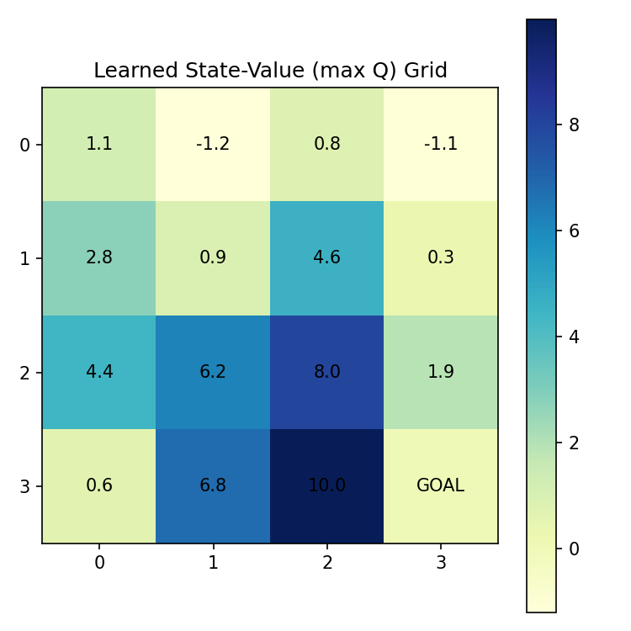
Fig 2.2 — Learned state-value (max Q) grid
Convergence behaviour and justification: the raw per-episode reward is noisy throughout training because the agent keeps a fixed ε = 0.2 exploration rate — it never stops taking a random action 20% of the time, so occasional poor episodes (e.g., wandering into an obstacle repeatedly) persist even late in training. However, the 10-episode moving average shows a clear and stable upward trend: it starts around −27 for the first 10 episodes (heavy step penalties while the agent explores blindly) and climbs to a stable plateau around +1 to +4 from roughly episode 40 onward, after which it no longer trends upward — indicating the greedy component of the policy has converged. This is confirmed by the value grid (Fig 2.2), which shows a smooth, monotonically increasing value-to-go as cells get closer to the goal, and by the policy grid, where all non-obstacle cells now point along a consistent shortest path toward the goal (state 15) rather than pointing in inconsistent/random directions. Average reward over the last 10 episodes (≈+1.0) compared to the first 10 (≈−26.6) confirms the agent has learned a substantially better policy than its initial random behaviour, with remaining fluctuation attributable purely to the fixed exploration rate rather than to instability in the learned Q-values.

